**Practical 1: Study of Data Definition Language Statement**

1. Write the query for the following
2. Create the following tables and include the necessary constraints NOT NULL, DEFAULT, CHECK, PRIMARY KEY, UNIQUE.
3. Student (sid ,sname, gender, dob, remark, marks, class, email)

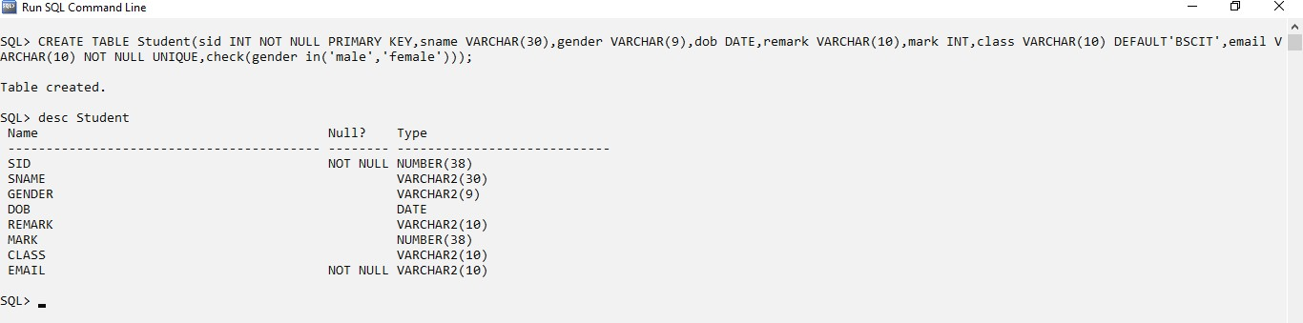

1. Course (cid, cname, credits)

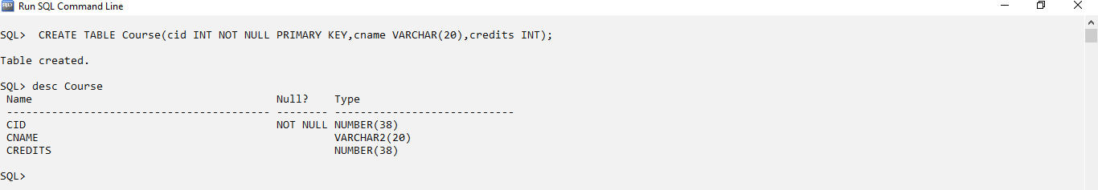

1. Alter the structure of the Course table
   1. 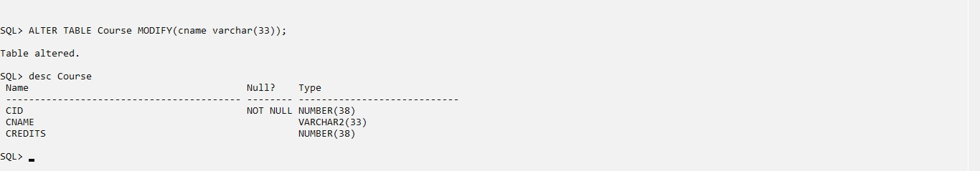Modify datatype of cname.
   2. Add a column coursehours with minimum course hours greater than 45.

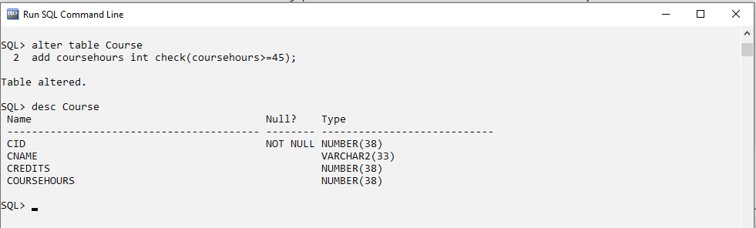

* 1. 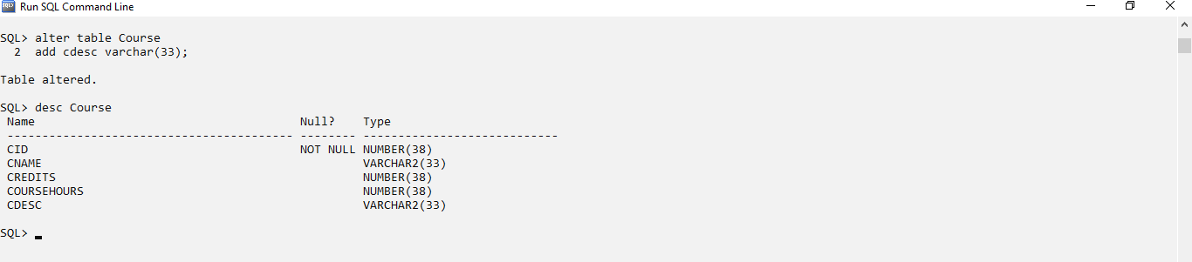Add a column cdesc

1. Alter the structure of Student Table
   1. Add column age with minimum age as 17.

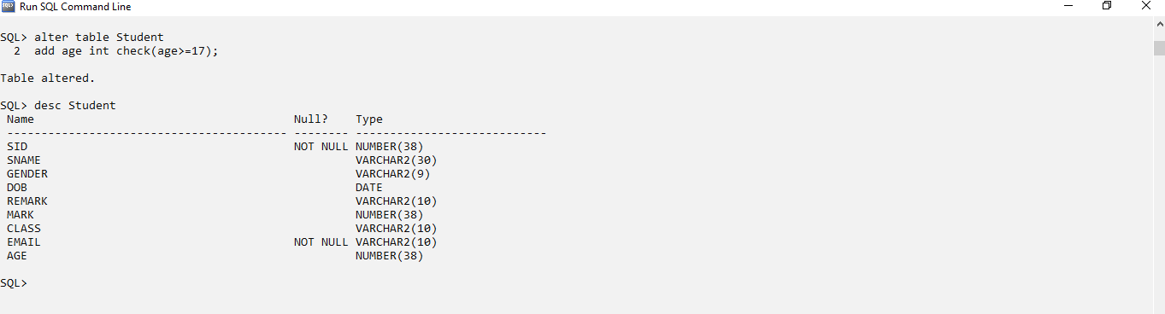

* 1. Delete the column dob

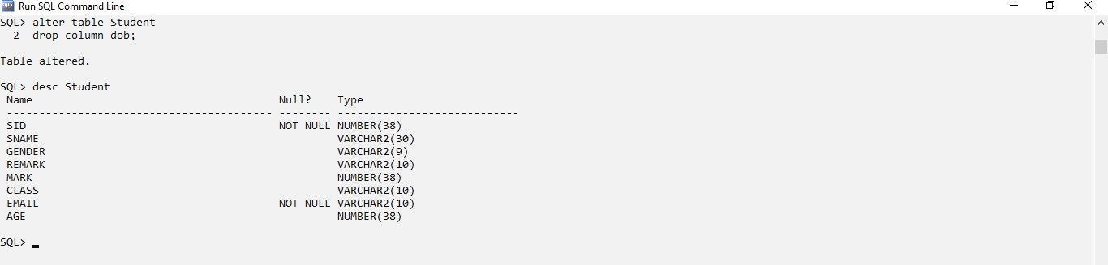

* 1. 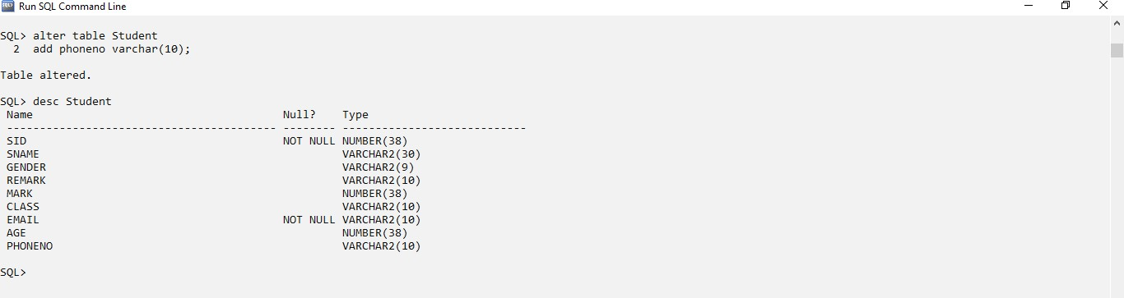Add a column phoneno.
  2. Rename phoneno to contactno

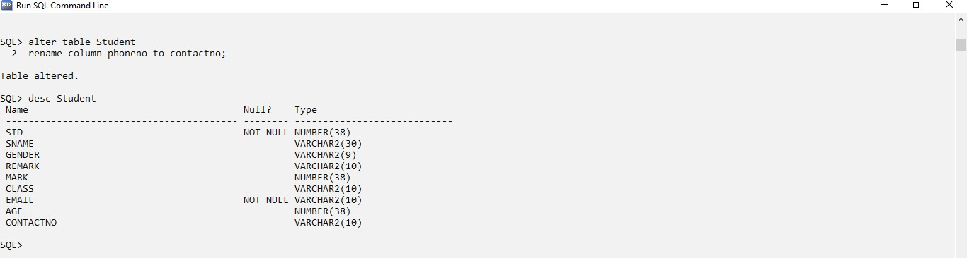

1. 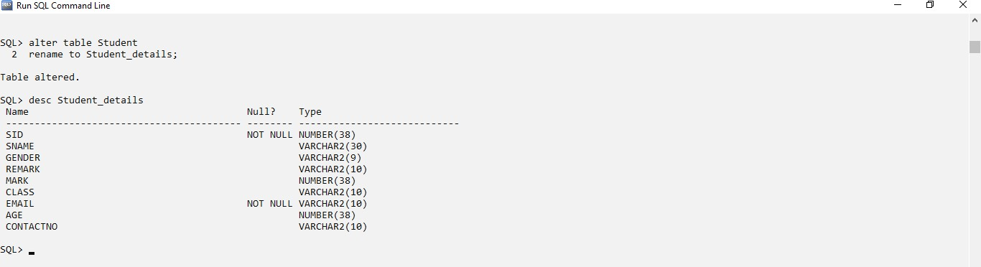Rename Student table as Student_details.
2. Describe the structure of both the tables.

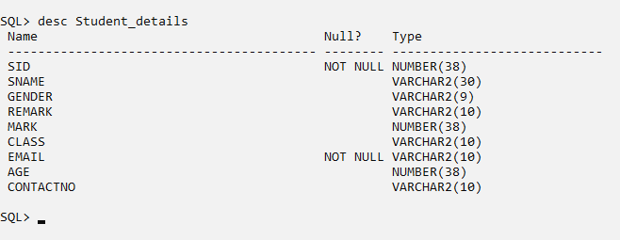

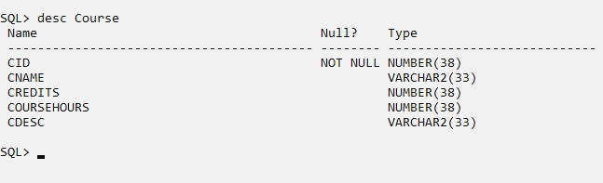

1. Drop the table student_details and Course. Drop the table student_details

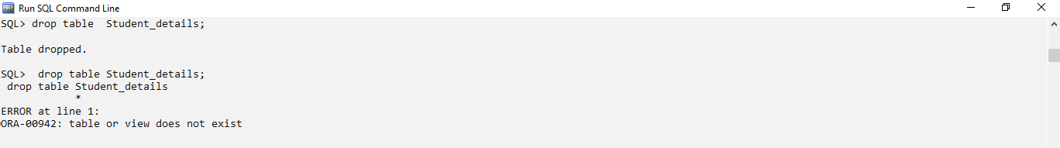

Drop the table Course

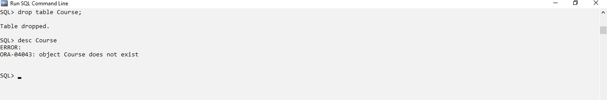

1. 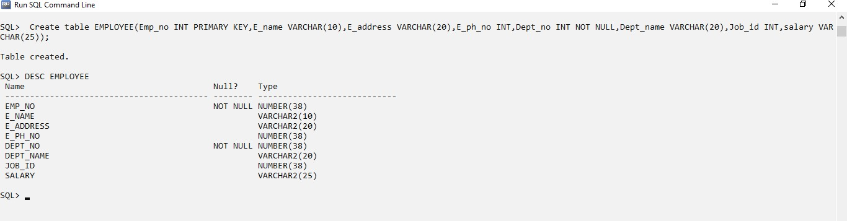1. Create a table EMPLOYEE with following attributes and specific data types and constraints required (Emp_no, E_name, E_address, E_ph_no, Dept_no, Dept_name,Job_id , Salary)
2. 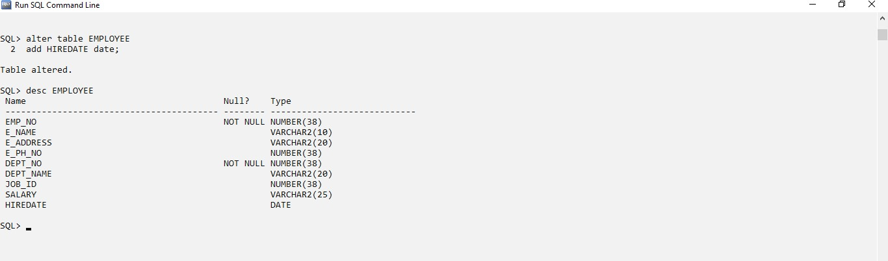Add a new column HIREDATE to the existing relation.
3. 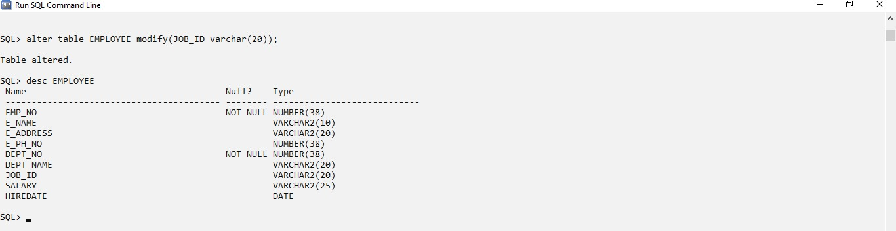Change the datatype of JOB_ID from char to varchar2.
4. Change the name of column/field Emp_no to E_no.

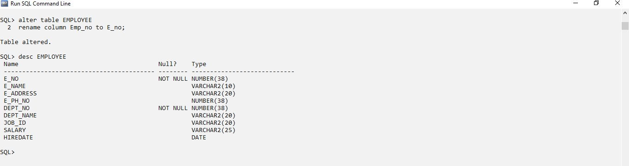

1. 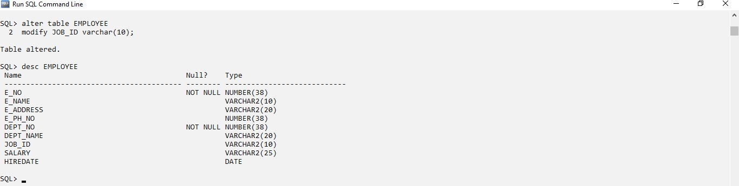Modify the column width of the job field of emp table.
2. Create the following tables with specified attributes and constraints

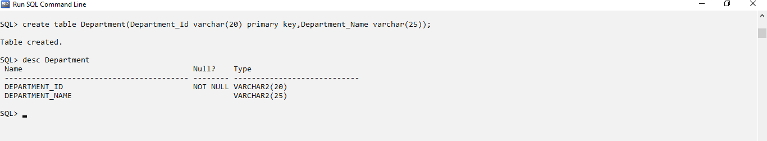Department Table: Department_Id varchar2(20) primarykey, Department_Name varchar2(25) with required data.

Instructor Table: Instructor_id varchar2(20) primary key, Department_Id varchar2(20) Foreign key, Last_Name varchar2(25), First_Name varchar2(200) must have value, Telephone varchar2(20) must be unique, gender char(1) must be either ‘F’or ‘M’,city varchar(10) default value must be ‘MUMBAI’.

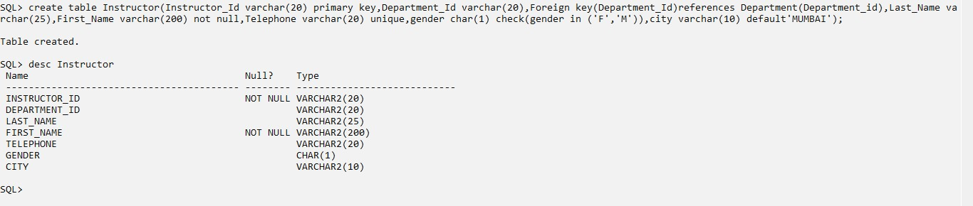

1. Create the following described below:

# Table Name: EMP

|  |  |  |  |  |  |  |
| --- | --- | --- | --- | --- | --- | --- |
| **Column** | **Data Type** | **Length** | **Precision** | **Scale** | **Primary Key** | **Nullable** |
| EMPNO | Int | - | - | - | Yes | - |
| ENAME | Varchar2 | 10 | - | - | - | No |
| JOB | Varchar2 | 9 | - | - | - | nullable |
| MGR | Int | - | - | - | - | nullable |
| HIREDATE | Date | - | - | - | - | nullable |
| SAL | Number | - | 7 | 2 | - | nullable |
| COMM | Int | - | - | - | - | nullable |
| DEPTNO | Int | - | - | - | - | nullable |

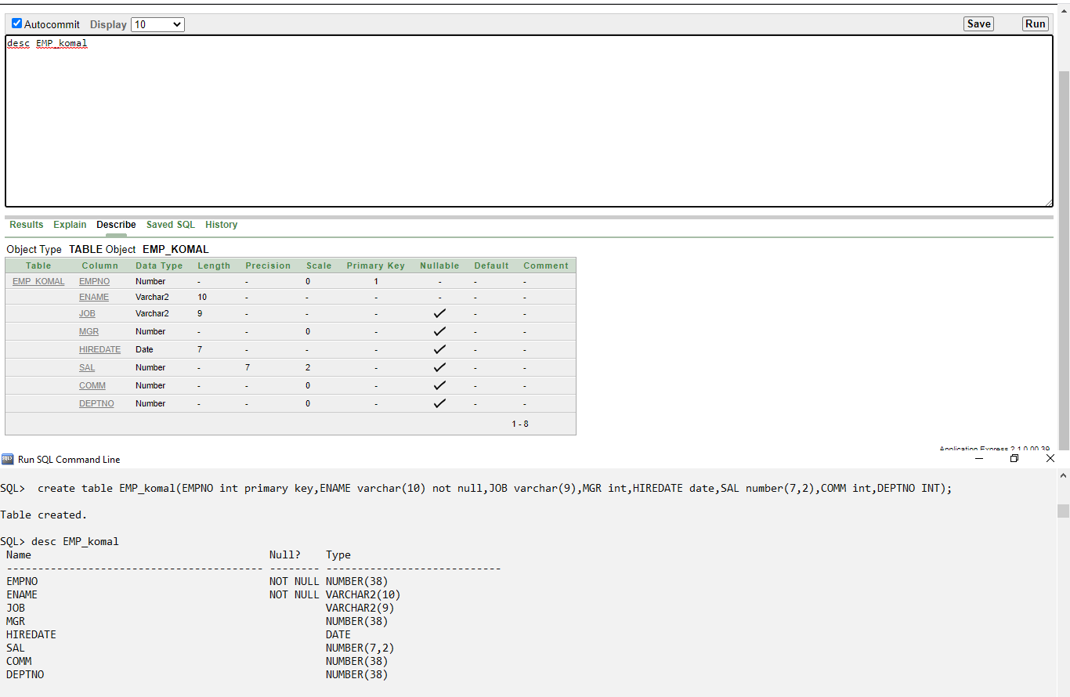

**Table Name: DEPT**

|  |  |  |  |  |  |  |
| --- | --- | --- | --- | --- | --- | --- |
| **Column** | **Data Type** | **Length** | **Precision** | **Scale** | **Primary Key** | **Nullable** |
| DEPTNO | Int | - | - | - | Yes | - |
| DNAME | Varchar2 | 14 | - | - | - | No |
| LOC | Varchar2 | 13 | - | - | - | nullable |

